

AJ Chapman, Jacob Kemp-Scheider, Nuha Syed, Sam Deane, Will Bertiz

Project 2 Design Doc

THE CALL

***When the Stone summons you, can you escape the Call?***

**Objective:**

Stealthily sneak past Warlock Hunters as you make your way to the Towers of Lumeth in order to tap into an alternative power source from the Towers of Lumeth in order to escape the Call.

**Narrative Context/Pitch:**

You are a warlock in Ethshar. Warlocky has just been outlawed in the Three Kingdoms due to its unknown nature and destructive potential. The Aldagmor Stone calls out to you and your fellow warlocks, driving you mad each passing day. As the Call resounds ever stronger, you hear of another power source at the Towers of Lumeth, and although you don’t know much about it, you believe it could cure you of the Call. With magical abilities at your disposal, you must run from the Call and make your way to the Towers of Lumeth while avoiding Warlock Hunters in your path.

**Win Condition:**

Reach the end location from your starting position on a grid based map over a series of turns by using your magical abilities to overcome obstacles while avoiding Warlock Hunters in your path. Once you reach the end location you continue to the next level until you reach the source of power in the Towers of Lumeth.

**Obstacles to Winning:**

* Warlock Hunters
  + If the player is spotted by a Warlock Hunters, they lose the level
* Environmental Obstacles
  + Brushes, rivers, and large boulders block your path
* Action Points Limit
  + The player can only perform a certain amount of actions per turn
* Puzzles
  + In order to reach your goal, you must sneak past Warlock Hunters while overcoming obstacles

**Rules/Game Logic:**

* Player movement
  + Point and click to move
* Get to the finish point
  + Reaching the finish point progresses the player to the next level
* Avoid Warlock Hunters
  + Enemies move when players move
    - Only certain enemy types can move and they move in predetermined patterns
  + Enemies have line of sight
    - Walking in line of sight results in failure of the level
* Objects
  + Can be interacted with by the player via abilities
  + Objects can be used to open new pathways and affect enemy movement
* Abilities
  + Player can click anywhere on the map to affect an object
  + Objects that can be interacted with are highlighted
* The player can restart the level at any time
* Basic Game Loop
  + Player moves or uses ability
  + Player ability resolves
  + All enemies move
  + Repeat until player reaches end goal or gets caught
    - Next level screen on end goal
    - Restart screen on being caught

**Game Prototype Screenshot:**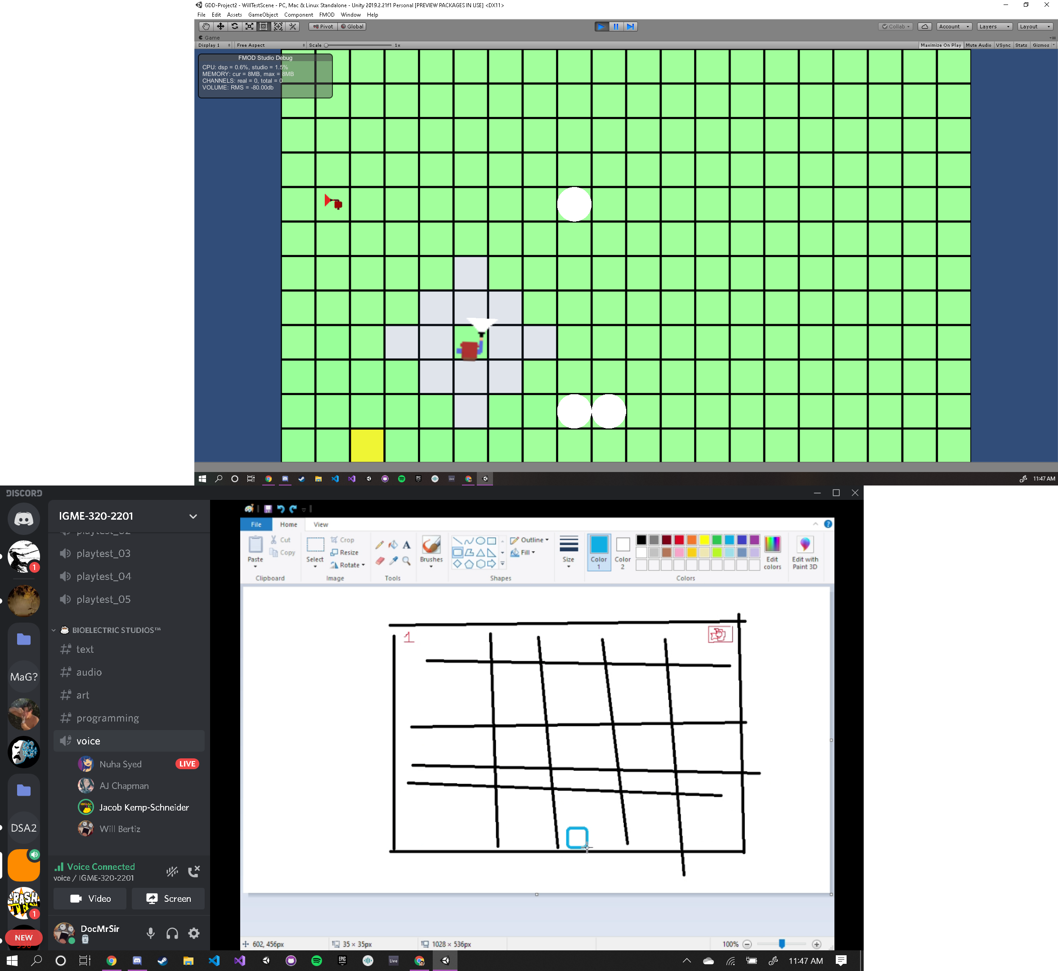

**Mechanics:**

* Abilities
  + Move Object
    - Cam move objects in order to block enemies
  + Rotate Object
    - Can rotate objects in order to make them face a new direction
  + Burn
    - Can burn objects in the path to open new paths
  + Freeze
    - Can create new paths out of ice or freeze enemies
* Grid Movement
  + Movement is confined to a grid within turns
* Simple Stealth
  + Player must avoid Warlock Hunters in their path
* Action Points
  + Determines how many actions a player can take in a turn

**Objects:**

* Player
  + Has a certain amount of actions points per turn
    - Moving and casting abilities uses action points
  + Players can right click on tiles that are highlighted
    - Depending on how far they travel a certain amount of action points are used
  + Can use abilities to affect other objects on the player’s turn
    - Abilities use action points on use
* Enemies
  + Warlock Hunter
    - Warlocks Hunters have a line of sight
    - Patrolling in a line, back and forth in one direction
* Immovable Objects
  + Walls or other parts of the mountain
    - Ex. Trees for our forest levels
* Interactable Objects
  + Moveable Objects
    - Boulders/rocks can be moved around with telekinesis for mountain levels
    - Warlock Hunters can be moved around with telekinesis
  + Burnable Objects
    - Brushes in forest levels
    - Melt ice to create water
    - Frozen warlock hunters can be unfrozen to continue their movement
  + Freezable Objects
    - Water creates an ice patch at that water tile
    - Freeze a puddle that a Warlock hunter steps in to stop them from moving

**Art:**

* Tile/Sprites Direction
  + Hand drawn
  + Cartoony, but still spooky
* GUI
  + Icons for each ability
* Mood boards:
  + Environments/Game View
  + Warlock Hunter Design
  + Player Warlock
  + Warlock Spells

**Mood Boards:**

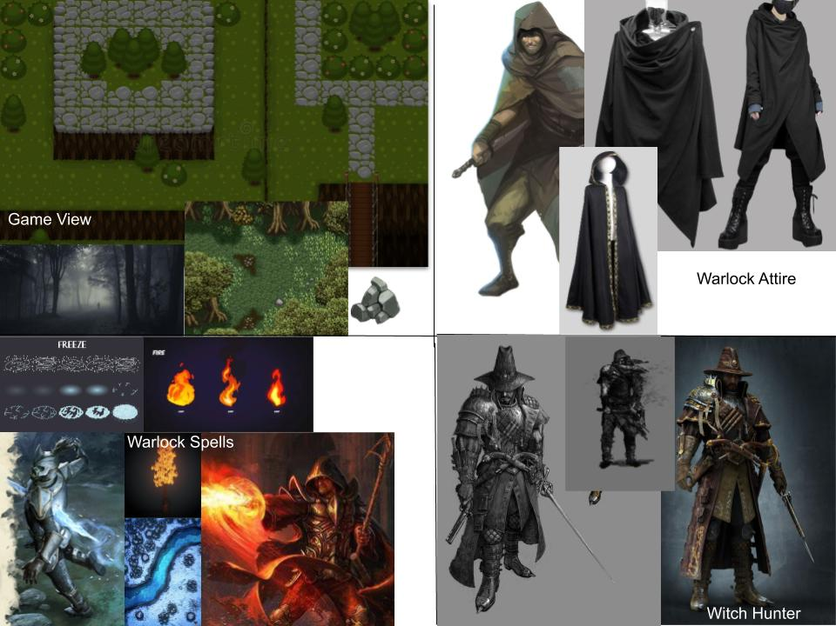

**Audio:**

* Audio direction
  + Stealthy/Tense
  + Fantasy
  + Spooky/Ominous
* Stretch goal: voice acting